LiteLLM
LiteLLM is a lightweight framework that lets you run and manage multiple LLM providers through a single unified API.
In simple terms, it works like a centralized gateway for AI models—whether they come from OpenAI, Anthropic, Google, Hugging Face, Ollama, or your own local models.
It simplifies the process of switching models, handling API keys securely, managing requests, logging usage, and deploying a fully functional AI gateway with minimal setup.

Key Benefits

Unified API for All Models
LiteLLM allows you to call different LLM providers using one consistent API style.
You no longer need different Python clients or SDKs for each provider—everything is standardized.

Self-Hosted Control
You can host LiteLLM locally or on a server using Docker.
This gives you full control over:
- model routing
- logging + monitoring
- API key security
- rate limiting
- team access
It behaves like your own private AI gateway.

Supports Dozens of Providers
You can connect:
- OpenAI
- Anthropic
- Google Gemini
- Meta Llama via TogetherAI
- Mistral
- Hugging Face
- Local models running on Ollama, vLLM, LM Studio, etc.
Everything is managed in one place.

Centralized Logging + Monitoring
LiteLLM includes built-in support for:
- usage logs
- cost tracking
- devtools interface
- request observability
This helps you compare AI model performance easily.

Prerequisites Before Installation
Before setting up LiteLLM, make sure you have the following tools installed:

1. Docker Desktop
LiteLLM runs through a docker-compose.yml file, so Docker Desktop must be installed.
What is Docker?
Docker is a tool that lets you run applications in isolated containers.
It ensures your environment runs exactly the same on any machine.
Download Docker Desktop:
https://www.docker.com/products/docker-desktop/
Install it and ensure Docker is running before continuing.

2. PostgreSQL 18 + pgAdmin 4
LiteLLM uses PostgreSQL as its backend database for storing:
- logs
- model credentials
- routing configurations
Download PostgreSQL 18 + pgAdmin:
https://www.postgresql.org/download/

Create the LiteLLM Database
After installing PostgreSQL and pgAdmin 4:
- Open pgAdmin 4
- Under "Servers", open your PostgreSQL connection
- Right-click Databases → Create → Database…
- Enter the name:litellm
- Click Save

How to Set Up LiteLLM (Docker Method)
Follow these commands in your command prompt:

1. Download the Docker Compose File
curl -O https://raw.githubusercontent.com/BerriAI/litellm/main/docker-compose.yml
This will create a folder name litellm and download docker-compose file
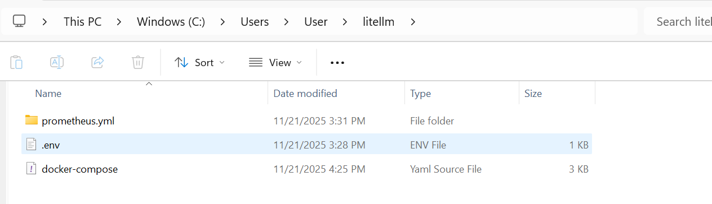

2. Add the Master Key
This key allows you to log into the LiteLLM admin dashboard.
echo LITELLM_MASTER_KEY="sk-1234" > .env
You can change this key later.

3. Add the Salt Key
This key encrypts your LLM provider API keys in the database.
Important: You cannot change this key after adding your first model.
LiteLLM recommends generating a secure random hash using:
https://1password.com/password-generator/
Add your salt key:
echo LITELLM_SALT_KEY="sk-1234" >> .env

4. Load Environment Variables(Optional)
source .env

5. Start LiteLLM
docker compose up

Docker will automatically:
- launch the LiteLLM server
- connect to your PostgreSQL database
- start the admin dashboard
- expose API endpoints for use in your apps
Once that is run successfully you should see this output. You now can access LiteLLM using http://localhost:4000/

Using the LiteLLM Admin Panel
Once LiteLLM is running, open your browser http://localhost:4000/ and navigate to the LiteLLM Admin Panel on/ui.

Sign In
Use the default credentials:
- Username: Admin
- Password: LITELLM_MASTER_KEY (the key you set earlier)
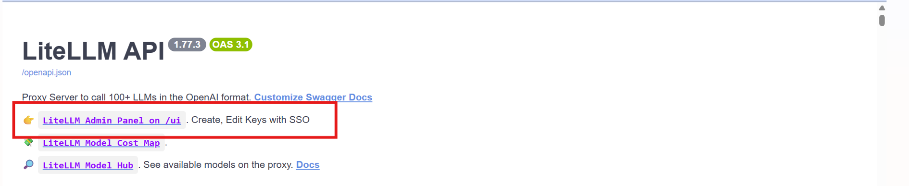

Adding Models in the Admin Panel

1. Go to: Models + Endpoints
This section allows you to register new models into your LiteLLM gateway.

2. Click “Add Model”
Here you will specify:
- Provider (OpenAI, Anthropic, Groq, etc.)
- Model Name / Mapping
- API Secret Key

3. Paste Your API Key
Copy your secret API key from the provider and paste it into the credentials field.

4. Test Connection
Click Test Connect to ensure that:
- your API key works
- the provider is reachable
- the model is valid
If everything is correct, LiteLLM will confirm the connection.

5. Add the Model
Click Add Model to save it.
You can repeat this to add as many models as you want.

Testing Models + Using the Built-In Chat

1. Go to the “Usage” Tab
This page shows:
- all API calls
- status codes
- model costs
- request logs

2. Test an API Key + Model
In the Test Key section:
- Choose the API key source
- Select the model you want to test
- Type your message into the chat box
LiteLLM will run the request using your configured model and show the response instantly.

